Computing Systems assignment 3- Operating systems
Microsoft Windows
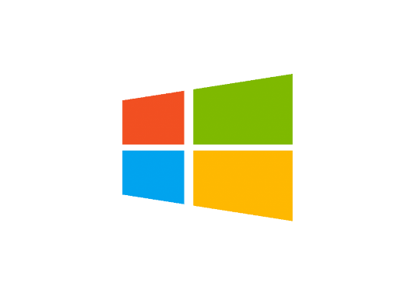
What is an operating system: an operating system is a powerful program that controls and manages the hardware and the software of a computer. The one I will be discussing is Microsoft windows.

History and descriptions of Microsoft Windows
- Microsoft is a multinational company. Microsoft created the Windows operating system on November 20th, 1985. The operating system featured the first graphical user interface (GUI) for IBM-compatible PC’s(international business machines), the Windows OS became the most dominant OS in the market with more than 90% of PC’s running on some version of Windows.
- Windows is available on 32 and 64-bit versions and offers a (GUI), multitasking functionalities, virtual memory management capabilities and support for several peripheral devices.
- Windows 3.1 (1992)
- Windows 95 (1995)
- Windows XP (2009)
- Windows 7 (2009)
- Windows 10 (2015)
- Windows 11 (2021)
Microsoft Windows has had a major impact on the world of IT more than any other OS. It was founded by Bill Gates and Paul Allen.


- Windows is a desktop operating system developed by Microsoft. Each windows version comes with a graphical user interface that displays a desktop with icons and a task bar that is at the bottom of the screen which allows quick and easy access to applications. The Windows “file explorer” enables users to open multiple windows, browse folders, and open files and applications. Most windows versions include a start menu, which provides quick access to files settings and the window search features.
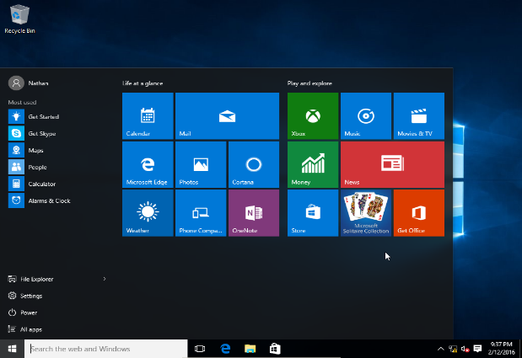
- It is an operating system for devices such as computers and tablets. It provides a way to stores files, run software, watch videos, play games and connect to the internet.
- Windows has a built in mechanism to keep the software updated which ensures you are up to date with Microsoft Windows ensuing maximum efficiency.

Process Management
Process management is the most important part of Windows operating systems. The operating system must allocate resources that enable processes to share and exchange information. Process management includes several tasks such as creation, scheduling, termination of processes, and a dead lock. It also protects the resources from each process.
How does Microsoft Windows implement process management?
Windows is responsible for the following activities regarding process management:
- Scheduling processes and threads on the CPUs.
- Creating and deleting both user and system processes.
- Suspending and resuming processes
- Providing mechanisms for the process synchronization
- Providing mechanisms for process communication

- Creation: process is created, joins the ready queue(main memory) and will be ready for execution.
- Scheduling: the operating system chooses one process and start executing it from the ready queue. Selecting the process which is to be executed next is known as scheduling.
- Execution: once the process is scheduled for execution, the processor starts executing it. If the process becomes blocked during the execution then the processor starts executing the other processes.
- Deletion: once the purpose of the process gets over then the OS will delete the process. The content of the process will be deleted and the process gets terminated by the operating system.
Schedular: Process Scheduler is the part of the kernel in charge with the strategy for allocation/de-allocation of the CPU. It determines which process will use the CPU next, and how long that process has to run. It maintains a record of all processes in the OS (via a process table), introduces new processes to this pool and removes the ones that completed. The dispatcher is the component of the kernel that oversees the execution of the scheduled processes which is achieved by multiprogramming. It performs process switch to change from one process to another.
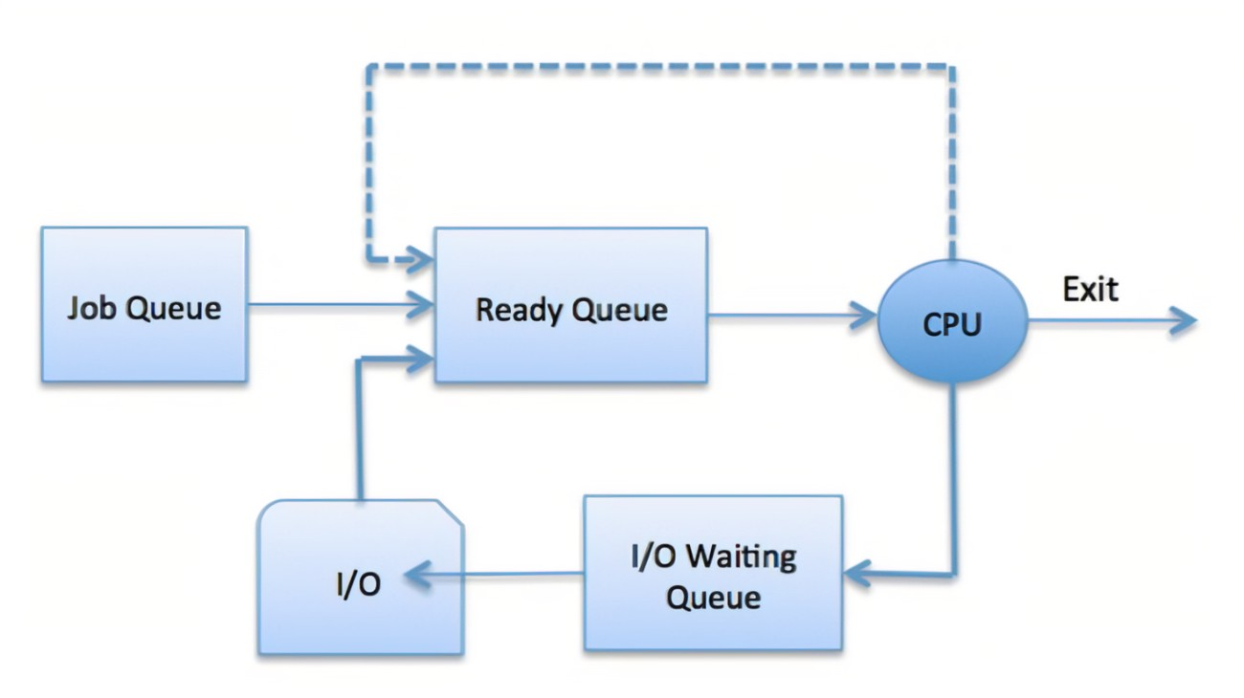
Deadlock: is a situation where a set of processes are blocked because each process is holding a resource and creating competition for non-sharable resources. For example if two trains are on the same track in opposite directions, none of the trains can move. This compares to when two or more processes that hold some resources and wait for resources held by others.
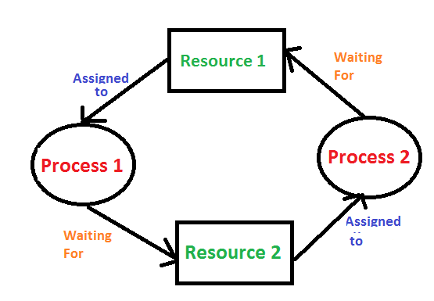

Memory Management
Memory management is the process of controlling and coordinating computer memory. It assigns portions known as blocks to various running programs to optimize the overall performance of the system.
How does Microsoft Windows implement memory management?
The Windows memory management helps processes to move back and forward between the main memory and execution disk. It helps the OS to keep track of every memory location, regardless of whether it is allocated to some process or it remains free.
Why do we use memory management?
- To check how much memory needs to be allocated to processes that decide which processor should get memory at what time
- Tracks inventory
- Allocate space to application routines and ensures of no interference between applications
- Protect processes from each other
- Places programs in memory so it is utilized to its full extent
Some memory management techniques include:
- Single contiguous allocation: all types of computer memory except a small portion which is reserved for the OS is available for one applications
- Partitioned allocation: divides memory into various memory partitions(mostly contiguous). Each partition stores all the information for a specific task or job.
- Paged memory management: divides the computer’s main memory into fixed-size units known as page frames. This hardware memory management unit pages into frames which should be allocated on a page basis.
- Segmented memory management: the only memory management that doesn’t provide the user’s program with a linear and contiguous address space. It needs hardware support in the form of a segment table which contains the physical address, size, and other data like access protection bits and status.

File Management
File management is the process of manipulating files in a computer system, its management includes the process of creating, modifying and deleting the files.
How does Microsoft Windows implement file management?
Microsoft Windows offers a built-in file explorer for file management. You can easily access the stored contents on your disk drive.
Objectives:
- Provides I/O support for a variety of storage device types
- Minimise chance of lost or destroyed data
- Helps OS to standardized I/O interface routines for user processes
- Provides I/O support for multiple users in a multiuser systems environment.
File structure:
- text file: series of characters that is organised in lines
- objective file: series of bytes that is organised into blocks
- source file: series of functions and processes
File attributes: the properties associated with a file that specifies the different information related to the file or data of the file. Key file attributes are:
- Name
- Identifier: unique tag number
- Location
- Type
- Size
- Protection
- Time, date, security
File operations: are the various task windows performs on files. A user can perform these operations by using the commands provided by the operating system.
File operations include:
- Creating
- Saving
- Opening
- Modifying
- closing
- Renaming
- Deleting
File access permissions: windows file access permission helps specify the manner in which a user can access a file. These are the access rights that allow us to read, write or execute a file.
Permissions include:
- read only
- write/modify the content
- execute: allows the user to run an existing file stored in the computer system.
File system: stores and organizes the various file and their information on a hard disk.
- File allocation table: used to organise files and folders in the form of a table(FAT). This system is used for disks that are smaller in size and contain simple folder. Examples: FAT12, FAT16, FAT32
- New technology file system: designed for large for performing basic file operations such as reading, writing, modifying, saving.

Device Management
Device management is responsible for managing all the hardware devices of the computer system. It may also include the management of the storage device as well as the management of all the input and output devices of the computer system.
How does Microsoft Windows implement device management?
Main functions:
- Tracks the devices and program, this is called input/output controller.
- Monitor the status of every device such as storage drivers, printers etc.
- Enforces pre-determined policies and decides which process gets the device and for how long.
- Allocate/de-allocate the device
- Optimize performance of individual devices.
Types of devices: Windows uses different devices to carry out the main functions of device management.
- Dedicated devices: assigned to only one job at a time until that job is complete, this applies to devices such as printers since only one user can instruct the printer to carry of its function at one given time.
- Shared devices: these devices can be allocated to multiple processes.
- Virtual devices: these are dedicated devices which can be transformed into shared devices

Features of device management:
- The OS interacts with the device controllers via the device drivers while allocating the device to the multiple processes executing on the system.
- Device drivers can be thought of as system software that bridge processes and device controllers.
- The device management function’s other key job is to implement the API
- Device drivers are software programs that allow the Windows operating system to control the operation of numerous devices effectively.
- The device controller used in device management operations mainly contains three registers, command, status and data.

References:
J Glenn Brookshear “Computer Science – An Overview”, ISBN: 0-321-54428-5
Microsoft Windows | History, Versions, & Facts | Britannica
https://guru99crack.com
https://www.geeksforgeeks.org
https://www.javatpoint.com/

